### 2.2: Rule Base

|  |  |  |  |  |  |
| --- | --- | --- | --- | --- | --- |
| **RULE BASE** | | | | | |
| **#** | **INPUTS** | | | **OUTPUT** | **Remarks** |
|  | **Soil Moisture** | **Humidity** | **Temperature** | **Irrigation** |  |
| 1 | DRY | LOW |  | HIGH |  |
| 2 | DRY | MODERATE | MODERATE | MODERATE |  |
| 3 | DRY | MODERATE | HIGH | HIGH |  |
| 4 | DRY | HIGH | ~MODERATE | MODERATE |  |
| 5 | MODERATE | LOW | LOW | MODERATE |  |
| 6 | MODERATE | ~HIGH | HIGH | HIGH |  |
| 7 | MODERATE | ~HIGH | MODERATE | MODERATE |  |
| 8 | MODERATE | MODERATE | LOW | LOW |  |
| 9 | MODERATE | HIGH | ~HIGH | LOW |  |
| 10 | WET | LOW | ~HIGH | LOW |  |
| 11 | WET | LOW | HIGH | MODERATE |  |
| 12 | WET | ~LOW |  | LOW |  |

### 2.3: Fuzzification Results

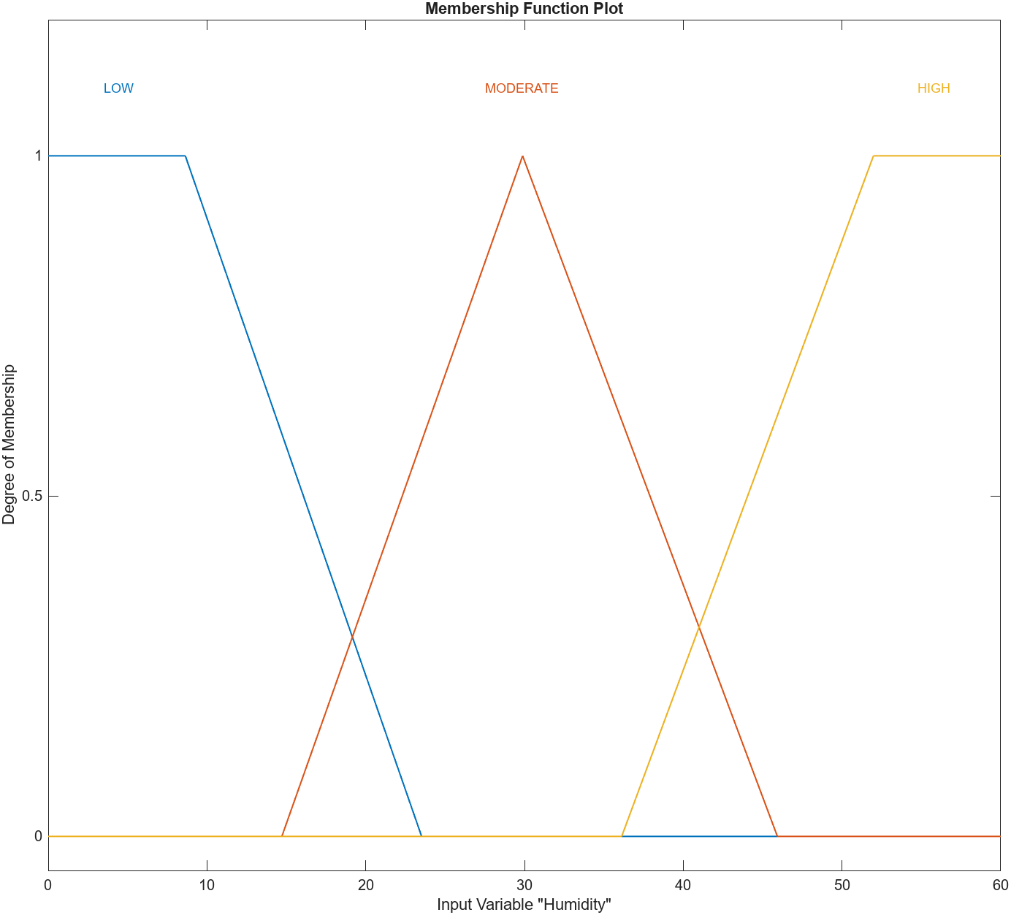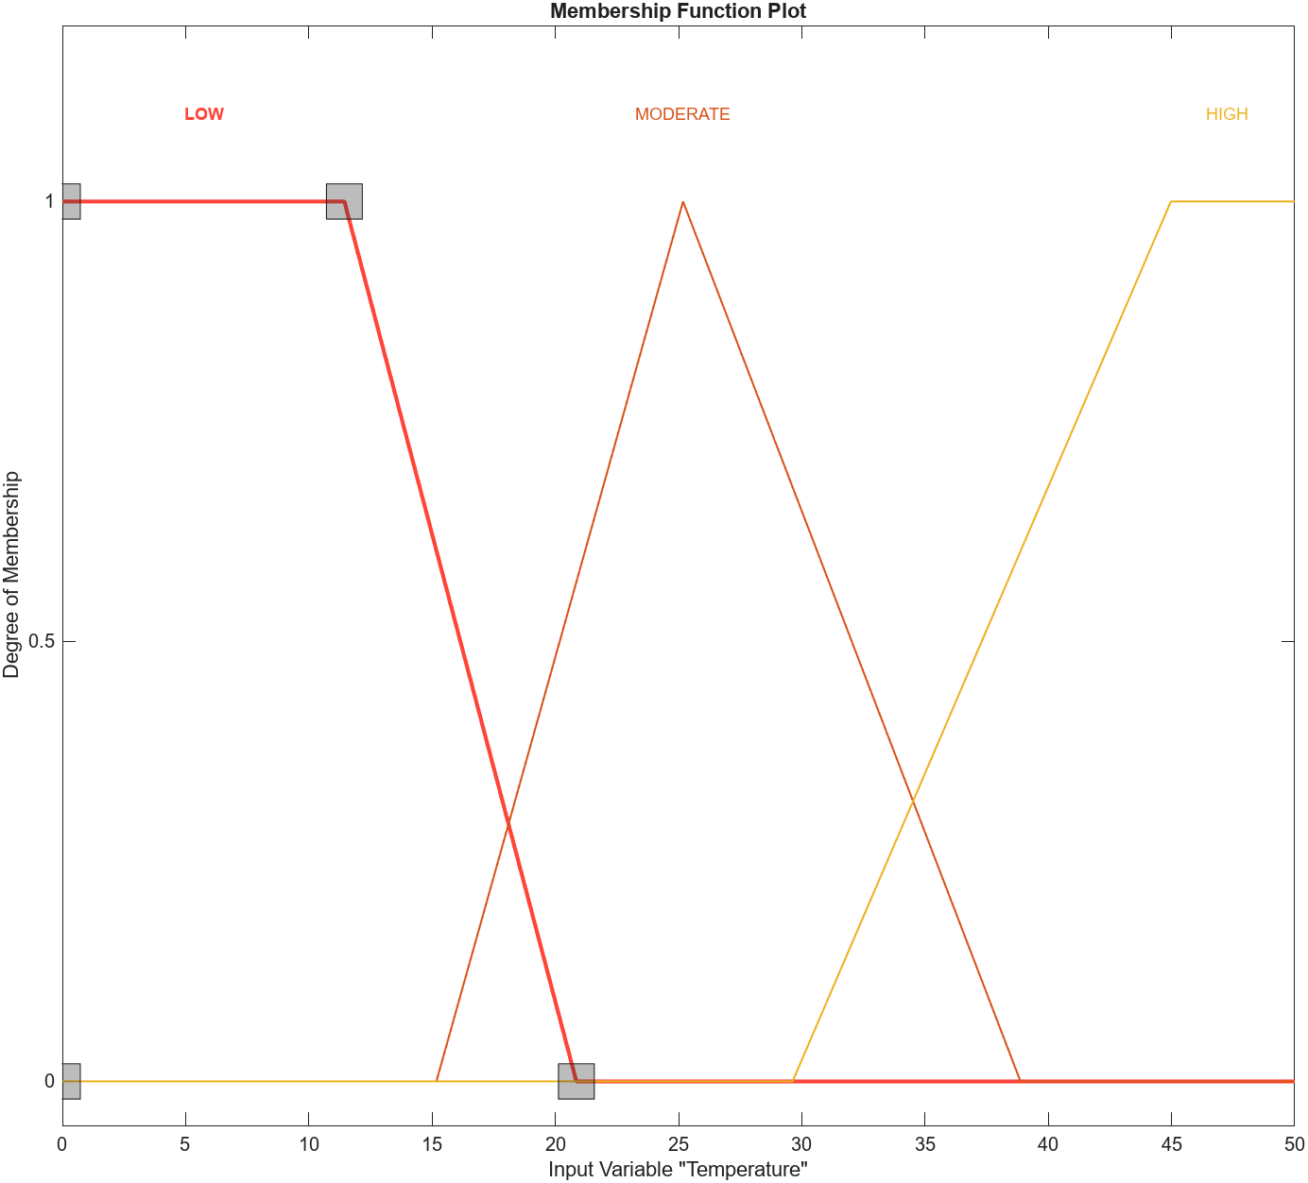

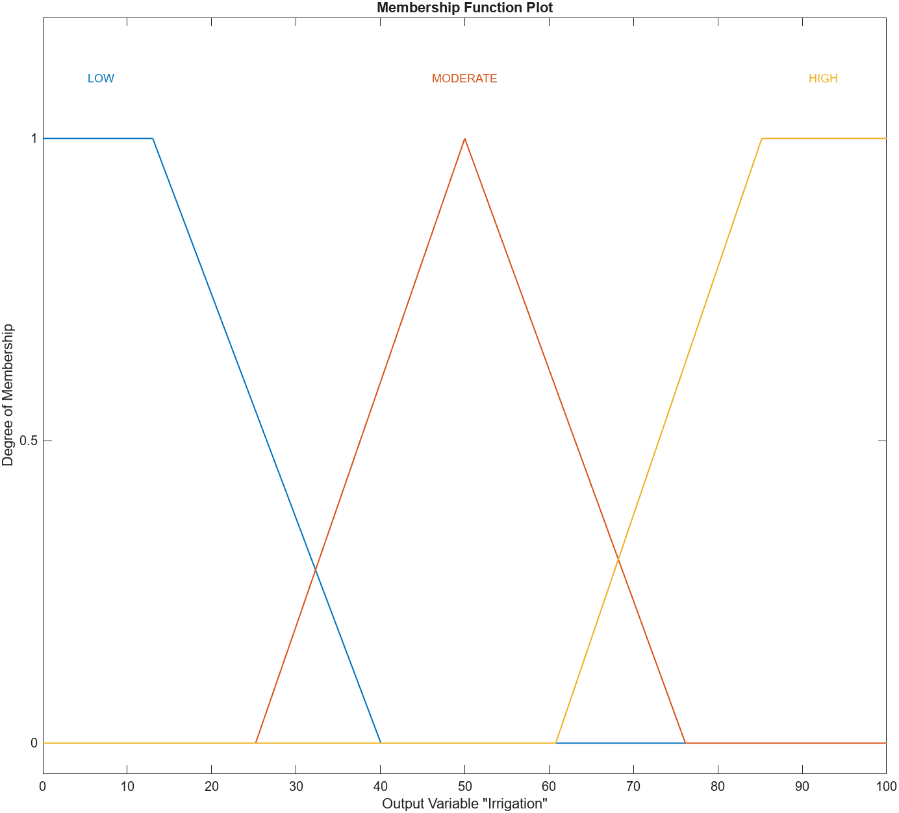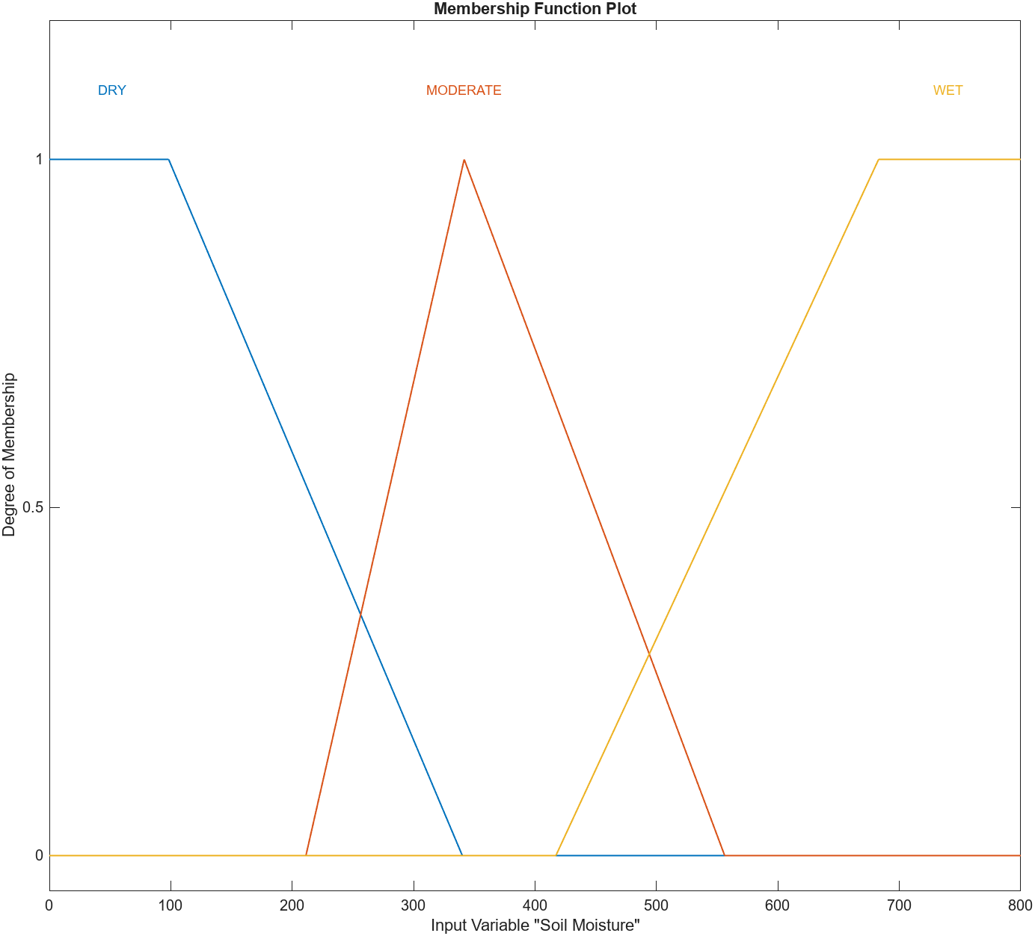

Fig. 4: Irrigation

Fig. 3: Soil Moisture

Fig. 2: Humidity

Fig. 1: Temperature

### 2.4: Rule inference

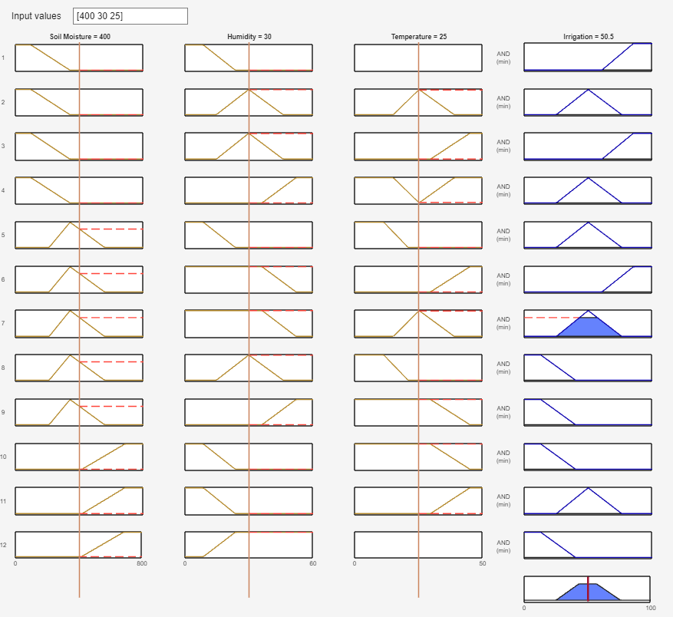

RULE AGGREGATION RESULT

## A diagram of a pyramid Description automatically generatedA graph of a graph Description automatically generated with medium confidence2.5 Results with Control Surface (Surf based Graphs)

Soil Moisture and Humidity Effect in Irrigation output

Soil Moisture and Temperature Effect in Irrigation output

## **APPENDIX 3:**

### 3.1 Effect of Membership Function

|  |  |  |  |  |
| --- | --- | --- | --- | --- |
| # | **Membership Function (MF) Name** | **Control Surf:**  **Soil Moisture and**  **Temperature** | **Control Surf:**  **Soil Moisture and**  **Humidity** | **Remarks** |
| 1.1 | Triangular (TRIM) MF |  |  | IBSBM3.1_1 |
| 1.2 | **Triangular (TRIM) MF (Optimized)** |  |  | IBSBM3.1_2 |
| 2.1 | Trapezoidal (TRAP)MF |  |  | IBSBM3.1_3 |
| 2.2 | **Trapezoidal (TRAP)MF (Optimized)** |  |  | IBSBM3.1_4 |
| 3.1 | Gaussian(GAUSS) MF |  |  | IBSBM3.1_5 |
| 3.2 | **Gaussian(GAUSS) MF (Optimized)** |  |  | IBSBM3.1_6 |
| 4.2 | **Generalized Bell MF (optimized)** |  |  |  |

## 3.2 Effect of Operators

## 

|  |  |  |  |  |  |
| --- | --- | --- | --- | --- | --- |
| **ANALYSIS OF FUZZY OPERATORS** | | | | | |
| **#** | **OPERATORS** | **METHOD ASSOCIATED WITH MATLAB** | **Based on Optimized FIS (3.2 in Appendix 3.1)** | **Remarks/**  **Conclusions** |  |
| Ob01 | AND (TNORM) | min |  |  |  |
| Ob02 | prod |  | The output values are closer to the boundary values. |  |
| Ob03 | OR (TCONORM) | max |  | Rules must be redefined. |  |
| Ob04 | prob or |  | Rules must be redefined. |  |
| Ob05 | sum |  | Rules must be redefined. |  |
| **ANALYSIS OF IMPLICATION OPERATORS** | | | | | |
| Ob06 | Mamdani’s  implication | min |  |  |  |
| Ob07 | Larsen’s  product | prod |  | Slight change observed in the graph. The values found is more promising that using min operator. |  |
| **ANALYSIS OF AGGREGATION OPERATOR** | | | | | |
| Ob08 | OR (TCONORM) | max |  |  |  |
| Ob09 | prob or |  |  |  |
| Ob10 | sum |  | sum operator found to be more refined while comparing with the boundary values. |  |
| **ANALYSIS OF DEFUZZIFICATION OPERATOR** | | | | | |
| Ob11 | Centre of Gravity | centroid |  | Smooth curve, no steep or sudden break in the graph, though it doesn’t provide the boundary values as output. |  |
| Ob12 | Centre of Area | bisector |  | It doesn’t provide the boundary values as result (output) in extreme conditions. |  |
| Ob13 | Middle of maximum | mom |  | This also gives best, but the clear edge is visible more compared to ‘som’ |  |
| Ob14 | Smallest of maximum | som |  | It found to be best to use since the test result found is best with ‘som’ |  |
| Ob15 | Largest of maximum | lom |  | Similar to ‘som’. |  |

## **APPENDIX 4:**

### **4.1 Test Results**

|  |  |  |  |  |  |  |  |  |  |
| --- | --- | --- | --- | --- | --- | --- | --- | --- | --- |
|  | **Test Results** | | | | | | | | |
|  | **INPUTS** | | | **OUTPUT (based on various Implementations)** | | | | | |
|  | **Soil Moisture (0 - 800 bars)** | **Humidity (0 - 60 g/m3)** | **Temperature (0 to 50 0C)** | **Irrigation Output- Benchmark A** | **Irrigation Output (Based on Triangular MF 1.2 under Appendix 3.1)** | **Irrigation Output (Based on Trapezoidal MF 2.2 under Appendix 3.1)** | **Irrigation Output (Based on Gaussian MF 3.2 under Appendix 3.1)** | **Irrigation Output (Based on Generalized Bell 4.2 under Appendix 3.1)** | **Irrigation Output (Based on OPTIMIZED OUPUT)** |
| 1 | 0 | 0 | 0 | 85.5 | 86.4 | 87.7 | 67.4 | 78.4 | **100** |
| 2 | 96 | 5 | 28 | 85.5 | 76.1 | 87.3 | 61.8 | 72.7 | **67** |
| 3 | 135 | 6 | 3 | 84.9 | 66.3 | 69 | 56.4 | 66 | **82** |
| 4 | 152 | 11 | 1 | 84.6 | 56.6 | 58 | 52.7 | 60.9 | **76** |
| 5 | 198 | 55 | 44 | 50.5 | 48.1 | 47.1 | 50.7 | 48.8 | **59** |
| 6 | 246 | 26 | 7 | 18 | 34.9 | 23.1 | 35.7 | 34.3 | **29** |
| 7 | 276 | 10 | 17 | 59.4 | 49.8 | 50.2 | 49 | 49.9 | **64** |
| 8 | 282 | 18 | 12 | 51.1 | 46.3 | 44.4 | 45.5 | 45.1 | **43** |
| 9 | 297 | 7 | 27 | 51.1 | 52.7 | 50.4 | 51.8 | 51.7 | **61** |
| 10 | 299 | 7 | 33 | 64.9 | 57.9 | 53.4 | 55.5 | 53.8 | **73** |
| 11 | 317 | 49 | 8 | 20.7 | 31.8 | 23.8 | 33.1 | 27.9 | **27** |
| 12 | 407 | 51 | 44 | 49.5 | 52.5 | 55 | 52.5 | 51 | **73** |
| 13 | 445 | 54 | 35 | 17 | 41.1 | 36.5 | 36.5 | 20.8 | **24** |
| 14 | 493 | 14 | 42 | 44.8 | 59.8 | 75.3 | 58.1 | 67 | **85** |
| 15 | 503 | 33 | 21 | 33.7 | 46.8 | 49.6 | 45.4 | 46.9 | **49** |
| 16 | 531 | 12 | 27 | 23.9 | 40.8 | 44.3 | 44.3 | 46.6 | **52** |
| 17 | 535 | 59 | 14 | 17.4 | 20.1 | 13.3 | 22.9 | 16.5 | **17** |
| 18 | 548 | 37 | 6 | 17.1 | 23.2 | 14.2 | 26 | 22.1 | **27** |
| 19 | 550 | 28 | 43 | 20.7 | 57.8 | 65.5 | 58.4 | 63.4 | **84** |
| 20 | 553 | 5 | 6 | 18 | 40.5 | 42.2 | 42.6 | 46.5 | **42** |
| 21 | 559 | 32 | 27 | 16.4 | 42.3 | 44.4 | 44.7 | 45.7 | **40** |
| 22 | 589 | 60 | 25 | 15.8 | 16.7 | 14.5 | 22.5 | 17.2 | **23** |
| 23 | 591 | 45 | 49 | 15.8 | 49.8 | 57.7 | 55.4 | 59.5 | **79** |
| 24 | 641 | 42 | 9 | 14.8 | 27.5 | 24 | 27.8 | 23.5 | **28** |
| 25 | 682 | 5 | 17 | 14.2 | 32.1 | 24.4 | 37.5 | 30.8 | **24** |
| 26 | 688 | 9 | 50 | 49.3 | 45.5 | 43 | 49.8 | 51.9 | **77** |
| 27 | 718 | 52 | 12 | 14.1 | 20 | 12.7 | 29.6 | 19.9 | **16** |
| 28 | 724 | 1 | 49 | 50.5 | 48.3 | 50 | 53.9 | 52.1 | **61** |
| 29 | 734 | 24 | 36 | 14.1 | 19.1 | 12.5 | 40.4 | 31.3 | **17** |
| 30 | 750 | 17 | 2 | 16.6 | 15.7 | 14.4 | 30.9 | 22.5 | **22** |
| 31 | 800 | 60 | 30 | 14.1 | 13.6 | 12.3 | 20.6 | 14.6 | **4** |
| 32 | 800 | 60 | 0 |  |  |  |  |  | **0** |

### 4.2 Optimized FIS system Results

#### FIS System Plot:

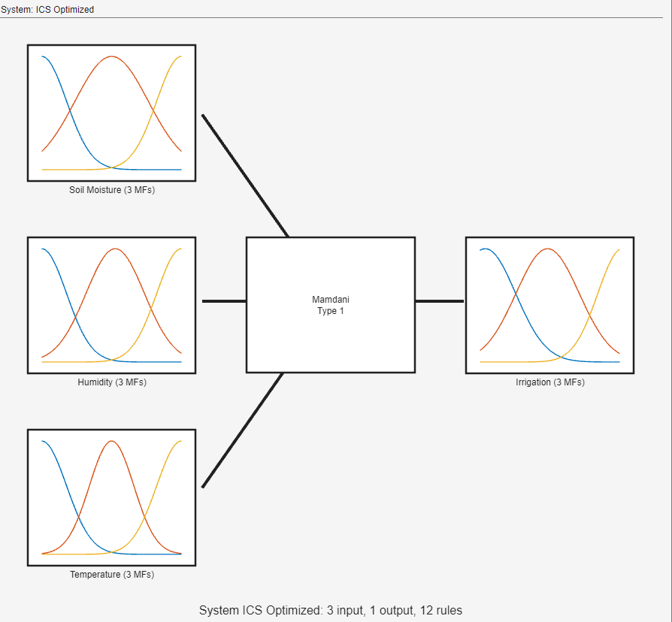

#### A screenshot of a computer Description automatically generatedRule Base in FIS:

#### Membership Functions



#### Rule Inference Result:

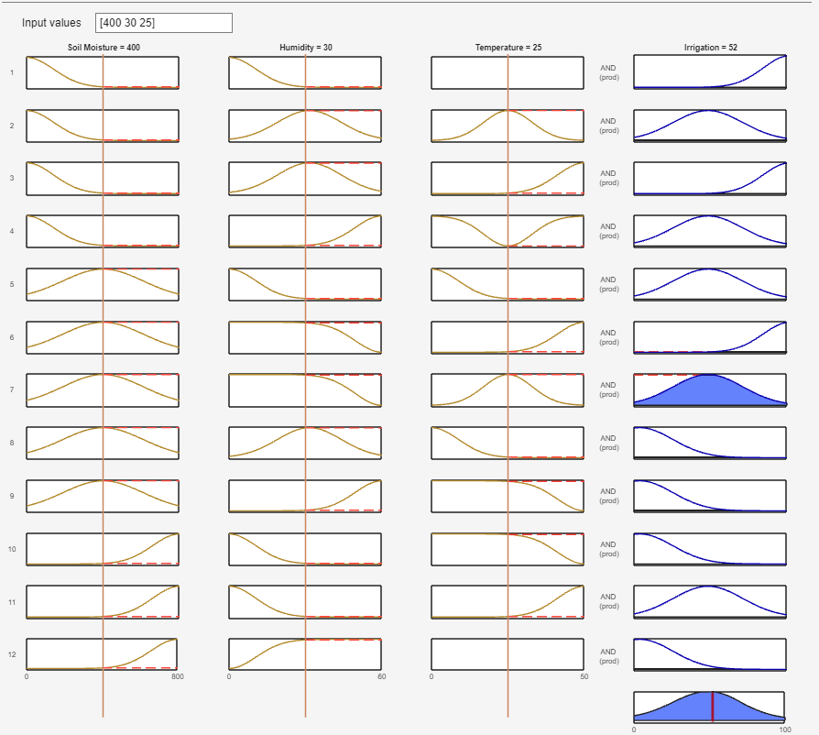

### 4.2 Explanation for the Result Obtained in Appendix 4.1